**INSTALLATION GUIDE – DT Printer**

**The following steps provide way to upload the pos.zip (Server zip) from web interface.**

1. Go to this path : C:\Program Files\Apache Software Foundation\Apache2.2\conf.
2. Take back-up of the file - httpd.conf.
3. Now, replace the httpd.conf file with the file given separately.
4. Restart the Apache service.

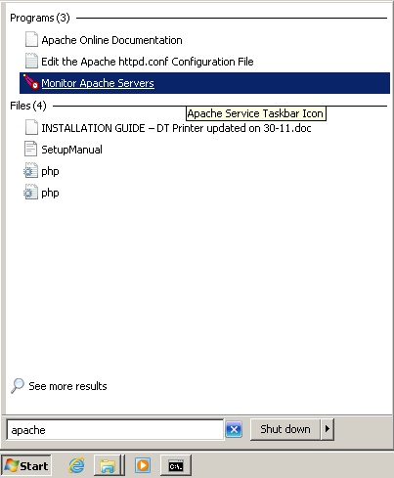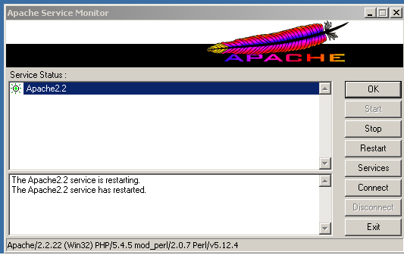

1. Go to this path : C:\php
   1. Take back-up of the file – php.ini
   2. Replace the php.ini file with the file given separately.
2. Configure network IP based on your IP address via TCP/IP network configuration.

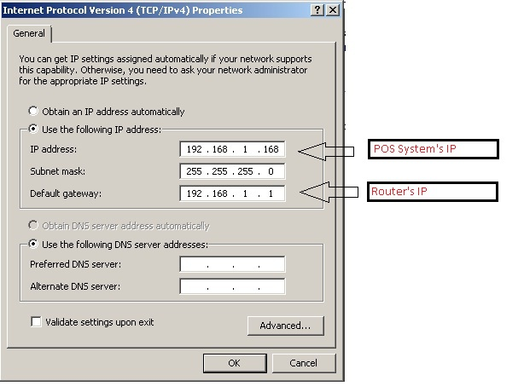

1. Steps to upload pos.zip from web interface (See the screenshot below)
   1. Open Webconfig,
      1. Click on WebConfig.html shortcut icon on desktop or
      2. Open this link in web browser [http://localhost/webconfig/](http://localhost/webconfig/#search/steps+to+setup+printer/_blank)
   2. Click Update settings in left navigation.
   3. In Manual update section, Upload pos.zip as given separately.
   4. Click to finish upload

Note : It can take 4-6 minutes to upload pos.zip, as it contains a lot small files and the process include upload and extract the zip file, so it takes time.

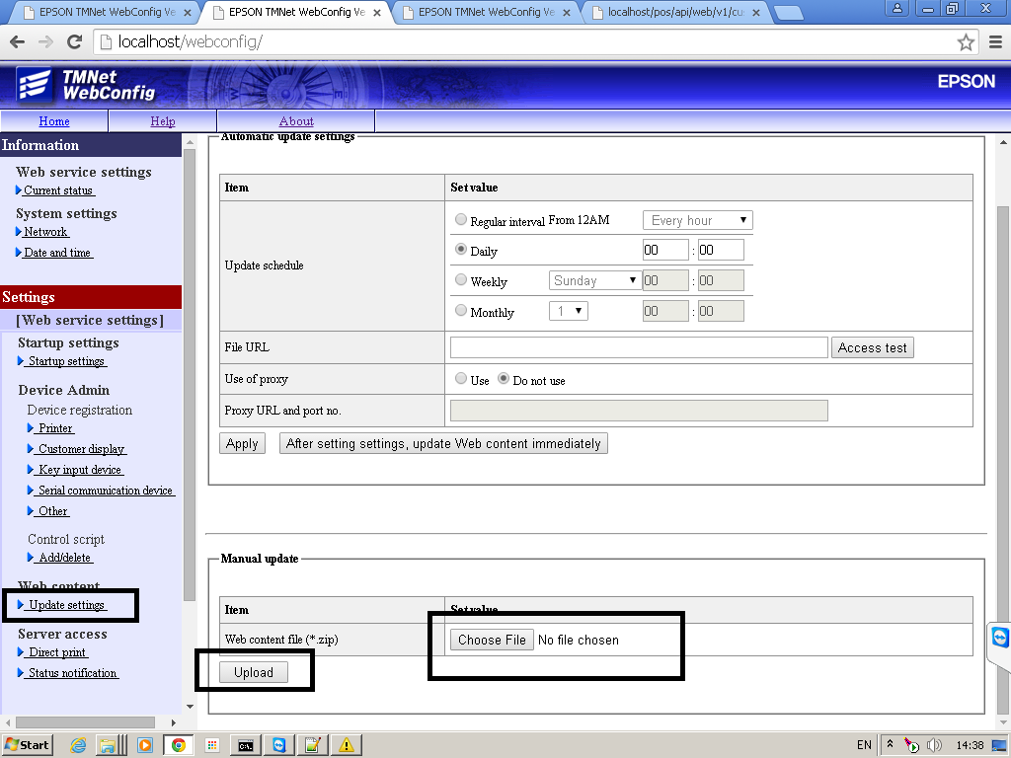

1. Registration of Devices

Register the device to be controlled by TM-DT. Configure the settings using EPSON TMNet WebConfig.

Configure the settings in the following procedure:

1. Start EPSON TMNet WebConfig from the shortcut on the desktop.

2. EPSON TMNet WebConfig starts. 

From [Web serv settings] - [Device registration], click an applicable item according to the device type to be registered.

|  |  |
| --- | --- |
| Item | Description |
| Printer | Used to set a TM printer to be controlled by TM-DT |
| Customer Display | Used to set a customer display to be controlled by TM-DT |
| Key input device | Used to set a key input device to be controlled by TM-DT |
| Other | Used to set other device to be controlled by TM-DT |

3. The setting screen for each device appears. Register the connected device into TM-DT

❏ **Printer**

Confirm that the local_printer is registered using the following procedure:

* + 1. Confirm that "TM-DT" is registered for the device ID "local_printer" in [Registered printers].
    2. Click [Test printing]. Ensure that "TEST_PRINT" is printed.

Register the connected network printer using the following procedure:

Set the following items and click [Add].

|  |  |
| --- | --- |
| Item | Description |
| Device ID | Enter the ID (any character string) of the printer to be controlled |
| Type | Select "Network printer" |
| Model no. | Select the model of the printer to be controlled |
| IP Address | Specify the IP address of the printer for each device ID. |
| Retry interval | Specify the retry interval after timeout |

**See below image for reference:**

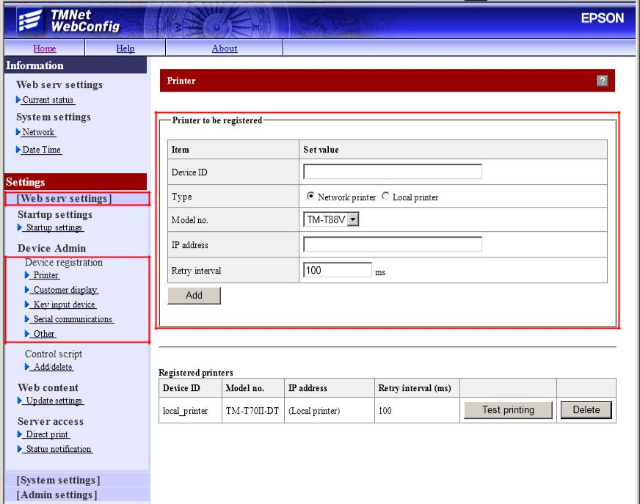

❏ **Customer Display**

Note: The device ID of the customer display is fixed to "local_display".

Register the connected customer display in the following procedure:

1. Select [Use].

2. Set the following items and click [Ok].

|  |  |
| --- | --- |
| Item | Description |
| Communications settings | Set the communication speed, data bit and parity. |
| Brightness settings | Set the brightness of the customer display. |

3. Click [Test Display]. Confirm that the characters are displayed on the customer display.

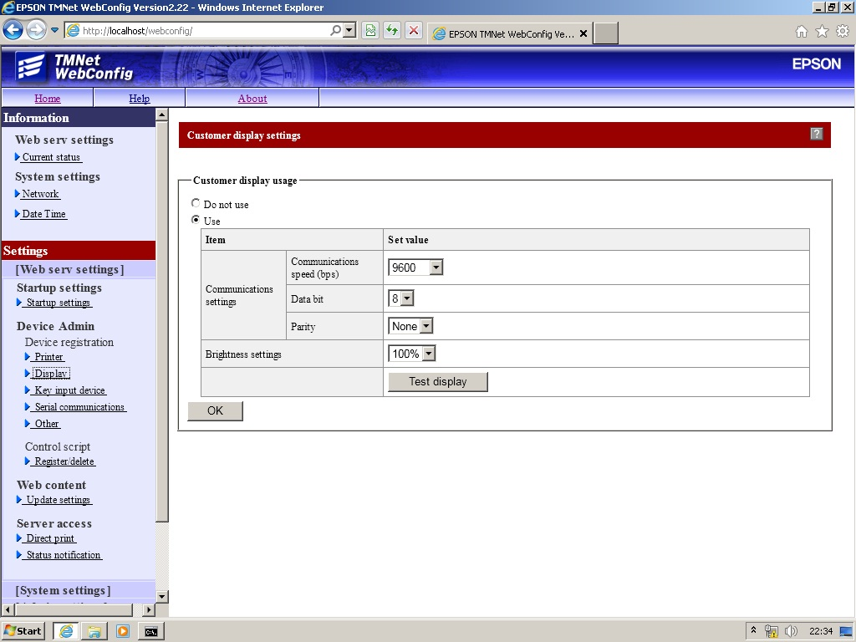

❏ **Key input device**

Register the connected key input device in the following procedure:

1. Set the following items and click [Add].

|  |  |
| --- | --- |
| Item | Description |
| Device ID | Enter the device ID (any character string). |
| Device name | Select the device name of the key input device. |
| Control Script | Select the device control script to be used for the key input device |

2. After confirming that the device is added to [Registered key input device], click [Operating test].

3. The screen appears. Operate the key input device and confirm that the operation result is displayed properly.

**See below image for reference:**

**Note: the selection of Correct Control JS is necessary otherwise devices will not work in Tablet app, Always select Scanner_Generic.js control script for MSR and Scanner.**

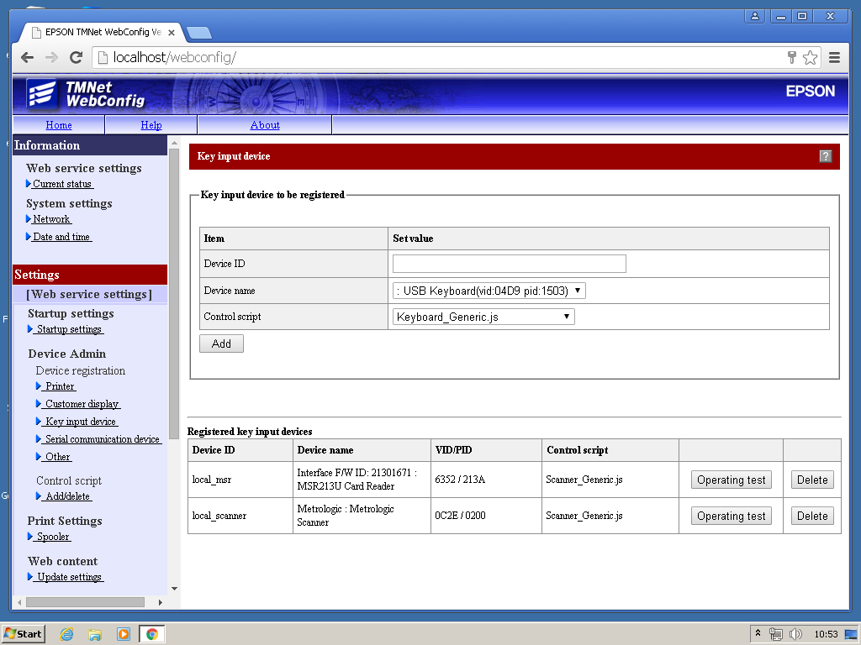

❏ **Other**

Register the connected device in the following procedure:

* 1. Set the following items for the connected device and click [Add].

|  |  |
| --- | --- |
| Item | Description |
| Device ID | Enter the device ID (any character string). |
| Control Script | Select the device control script to be used for the key input device |

2. Confirm that the device is added to [Registered Other Devices].